



**STARBOARD**

**BOW**

**PORT**

**STERN**

Contents

General Information 3

Inspection 4

Operating Procedure 8

Setup 8

Networking 10

Network Basics / Network Description 10

Setup for the Ubiquiti Bullet 15

Controller 16

[Wiring Diagram 18](https://usarmywestpoint-my.sharepoint.com/personal/tyler_errico_westpoint_edu/Documents/Documents/SeaRobotics/Sea%20Robotics%20-%20Surveyor%20SOP.docx#_Toc120000384)

[Rear Compartment Contents 19](https://usarmywestpoint-my.sharepoint.com/personal/tyler_errico_westpoint_edu/Documents/Documents/SeaRobotics/Sea%20Robotics%20-%20Surveyor%20SOP.docx#_Toc120000385)

[Adapter Board with Labeled Ports and LED Health Indicators 20](https://usarmywestpoint-my.sharepoint.com/personal/tyler_errico_westpoint_edu/Documents/Documents/SeaRobotics/Sea%20Robotics%20-%20Surveyor%20SOP.docx#_Toc120000386)

Uninterruptable Power Supply 22

Motor Controller 23

General Maintenance 25

Thruster Maintenance 26

Parts List 30

Sea Robotics Support Contacts 32

Change Log 32

Future Additions/Changes: 32

# General Information

* Boats require two people to carry them
  + Use proper lifting techniques
* Avoid putting hands near propellers
  + If not avoidable, ensure to remove the safety lockout lanyard
  + If possible, shutdown boat
* When storing boats, ensure to remove the antenna from the Ubiquiti Bullet to avoid damaging them.
* Remove any connector with care. They break easily

# Inspection

1. Open the “SeaRobotics Surveyor Health Document” (Include Location), and update health document with date of inspection and performer of inspection. Update Health Document as you perform inspection.
2. Inspection should be performed after boats have been in storage for extended periods of time, and after extensive use.
3. Be sure that when performing inspection that the boat is powered off (unless it’s necessary that it be powered on) and there is nothing obstructing the props, or any moving components, (i.e. the CPU cooling fan) and that there is nothing touching any exposed wiring.
4. Examine the outside of the outside of the boat for cleanliness and damage. Get a rag and remove any dirt and debris on the outside of the boat.
   1. Once clean look for any dents, chips, excessive scratches, holes, etc. Surface should look smooth and unbroken.
   2. Examine the rubber gasket that joins the upper and lower hull for damage.
   3. Ensure that all fasteners are present and undamaged. Carefully tighten fasteners with hand tools.
   4. Update the robot health document accordingly.
5. Examine the kill switch for any damage.
   1. Examine the rubber gasket on the switch and sure it is undamaged.
   2. Ensure that there is no gap between where the kill switch and outside surface of the boat interface.
   3. Test the kill switch by depressing it by hand. Remove pressure from the kill switch and the switch should return to its normal position.
   4. Examine the kill switch lanyard for damage. Attach lanyard to the kill switch to see if the lanyard interfaces properly with the switch. Once complete remove the lanyard from the kill switch and ensure that the kill switch returns to its active position.
   5. Update the robot health document accordingly
6. ENSURE THAT THE BOAT IS POWERED OFF AND THE KILL SWITCH LANYARD IS REMOVED FROM THE KILL SWITCH SO THAT THE KILL SWITCH IS ACTIVATED.
   1. Inspect the propellers for dents, chips, excessive scratches, corrosion, debris, etc. Inspect the propeller guard for integrity (i.e. dents, chips, excessive scratches, corrosion, debris, etc.).
   2. Inspect all fasteners on propeller and propeller guard assembly.
   3. Tighten all fasteners with hand tools while being careful not to strip any fasteners.
   4. All fasteners should be present. Make note of any fasteners that are missing or damaged (stripped, corroded, etc.) and arrange to have them replaced.
   5. Spin the propeller by hand and see if the propeller spins freely. If there is an audible whirring noise that means that the propeller is properly interfacing with the motor. If there is no noise and the propeller spins freely with minimal resistance than it is likely that the shaft pin has sheared and needs replacement.
   6. Update the robot health document accordingly.
7. Examine the on /off switch for damage.
   1. Ensure that there is no gap between where the on / off switch and outside surface of the boat interface.
   2. Actuate the switch to test its functionality. You should feel a solid click as it switches from one position to the other.
   3. Actuate the switch to its upward position. The indicator light located next to the switch should illuminate if the battery is plugged in and charged sufficiently. The indicator light should start blinking after a minute or two has passed.
   4. Flip the switch to the off position. It should take a few minutes for the indicator light to turn off and for the boat to fully shutdown.
   5. Update the robot health document accordingly.
8. Examine the USB port covers. Both should be present and undamaged.
   1. Ensure that they thread on securely to their ports.
   2. Remove the USB port covers and examine the USB ports.
   3. Ensure there is an orange gasket present around the ports.
   4. The threading should be undamaged.
   5. The USB port itself should be undamaged. Test the USB ports by plugging in USB device to see if it fits in securely.
   6. Ensure that there is no gap between the USB ports and the external surface of the boat.
   7. Ensure fasteners on the USB port panel are tightened and undamaged. Arrange to have them replaced if damaged or missing.
   8. Reattach the USB port covers once inspection is complete.
   9. Update the robot health document accordingly.
9. Examine the compartment panels on the top surface of the boat for cleanliness and damage.
   1. Clean any dirt and debris from the compartment lid with a rag if any is present.
   2. Once clean look for any dents, chips, excessive scratches, holes, etc. Surface should look smooth and unbroken.
   3. Ensure all fasteners are present and undamaged. All fasteners should also have washers that are present and undamaged.
   4. If fasteners / washers are missing, or damaged arrange to have them replaced.
   5. Remove the top panels and examine their undersides for damage. Ensure that when you examine the underside of the panels the fasteners don’t get lost. Keep track of which panels belong to each boat because they all fit a little bit differently.
   6. Examine the gaskets for each compartment lid for damage. Ensure that the gasket is attached firmly to either the lid or the body of the boat itself.
   7. Update robot health document accordingly.
10. Examine the internal compartments.
    1. Each compartment should be clean.
    2. All compartments should have all fasteners present. Carefully retighten them by hand.
    3. All wiring connections should be secure. Having the boat powered on to examine the indicator lights on the adapter board might be useful to see if everything is connected and working properly. (See section on adapter board)
    4. Update robot health document accordingly.
11. Examine the battery.
    1. Ensure that the battery is clean and undamaged.
    2. Examine the battery connectors and ensure that they are clean, undamaged, and are not corroded.
    3. Test the fitment of the connectors by disconnecting the and connecting them. The connectors should fit securely together without having to using excessive force to connect and disconnect them.
    4. Update robot health document accordingly.
12. Examine the antenna for damage.
    1. Ensure antenna attaches securely to boat.
    2. Ensure antenna powers on when the boat is powered on.
    3. Check Ubiquiti Bullet to see that it is properly threaded into its base. DO NOT rotate the Ubquiti Bullet but rotate the collar that connects the bullet to the hull of the boat. Rotating the Ubiquiti Bullet can damage the wiring inside the boat.
    4. Update robot health document accordingly.
13. Examine the charging port on the rear of the boat for damage
    1. Remove the cover by twisting counterclockwise until it is loose.
    2. Examine the terminals and ensure that they are clean, undamaged, and are not corroded.
    3. Charging port caps should have tethers that keep them attached to the boat. Ensure that the tethers are undamaged.
    4. Reattach the cover once inspection is complete.
    5. Update robot health document accordingly.
14. Examine Pelican Case for damage.
    1. Ensure that the pelican case properly locks.
    2. Ensure that rubber gasket is undamaged.
    3. Ensure that ports on back of pelican case are undamaged and that all port caps are present. Test the functionality of the power switch. There should be a solid click when switching it from one position to the other.
    4. Ensure that the fuse on the back of the pelican case, above the power port, is pressed all the way in.
    5. Open the pelican case and ensure that there is a laptop, a radio ethernet cable, a laptop ethernet cable, a power cable, a laptop charger, a USB extension cable, and a controller. Ensure that the cables are in good condition.
    6. Remove the cable and examine the internal components of the pelican case. All wires should be plugged in, and the wiring should be undamaged.
    7. Plug in the power cable and flip the power switch to the on position. There should be two green indicator lights to signal that the electronics are operating normally.
    8. Plug in the radio ethernet cable into the radio ethernet port and into the radio mast. There should be a secure connection and the radio on the mast should light up to show that it has powered on.
    9. Plug in the laptop ethernet cable into the laptop ethernet port and into the laptop. When the laptop is powered on you should see on the network switch in the pelican case that there are blinking lights next to the laptop port and radio port. If there are no blinking lights, ensure that each cable is firmly plugged in to its respective ports.
15. Test the functionality of the boat.
    1. Power on the boat, wait until the boat finishes its power on sequence, and open the GUI on the laptop.
    2. Once communications have been established with the boat, connect the controller with the laptop.
    3. Ensure that the props on the boat are completely unobstructed and that the kill switch lanyard is attached.
    4. Use the controller to spin the props. There will be a slight delay between controller inputs and when the motors spin. The delay will be more significant if the controller is further away from the base station laptop and if the boat is further away from the radio mast. The props should stop and start at approximately the same time. The props should not freely spin if the motors have stopped moving. If they do that is indicative that the shear pin needs replacement.
    5. Move the sticks on the controller so that the props are spinning and then press the ‘X’ button. The props should stop moving and the GUI should say that the boat is in standby mode.
    6. Put the boat back into thruster mode by clicking the left stick. Once again, move the sticks on the controller so the props are spinning and then remove the kill switch lanyard. The props should stop moving.

# Operating Procedure

## Setup

1. Setup folding tables.
   1. Setup tables so that you have enough surface space to setup the networking equipment for the number of boats you’re using and to have some additional workspace for the onshore computer, and any additional computers.
      1. Recommended 1 table per every two companion computers being used and an additional table for shoreside computer / personal computers.
   2. The table that supports the networking equipment should be in a position that is close enough to the water so an ethernet cord can run from one pelican case to the radio mast that should be positioned on the dock. You should also have a good view of the water, so you have as much of an unobstructed view of the playing field as possible.
2. (Optional) Set up chairs.
3. (Optional) Set up pop-up tents.

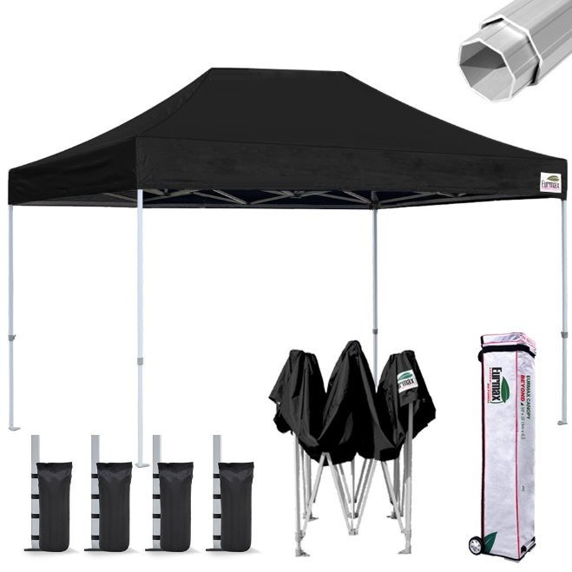

* 1. Primarily for comfort and protection from elements.
  2. If it is excessively windy DO NOT set up the tent. It will break, get blown away, and there is high potential for someone to be hurt or equipment to be damaged.
  3. Ensure to weigh down legs with provided weights. Will have to fill weights with water.

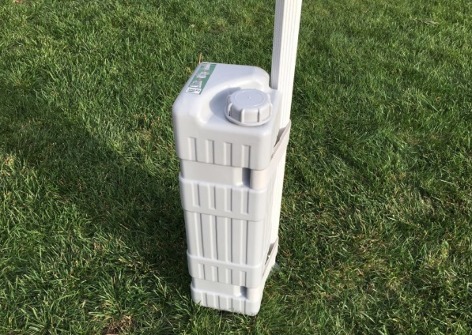

1. Gather materials.
   1. One pelican case per boat.

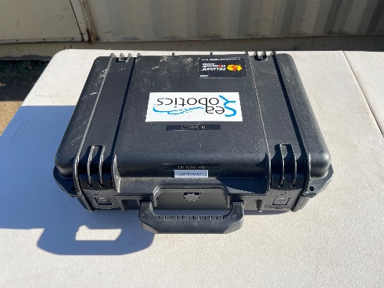

* + 1. Each pelican case is labelled to correspond with its respective boat i.e., you will need to use laptop 2 to communicate with and control boat 2.

|  |  |
| --- | --- |
|  | (INSERT PICTURE BOAT WITH BOAT NUMBER) |

* + - 1. Settings can be changed on the computer to be able to connect to other boat IP addresses if necessary.
    1. Each pelican case contains:

|  |  |  |
| --- | --- | --- |
| 1. | Laptop / Companion Computer |  |
| 2. | Network Switch |  |
| 3. | Power Supply for providing power over ethernet for the radio port |  |
| 4. | One “Radio” ethernet cable with weatherproofed connection at one end intended to attach to the external “Radio” ethernet port on the pelican case |  |
| 5. | One “Laptop” ethernet cable with weatherproofed connection at one end intended to attach to an external ethernet port on the pelican case |  |
| 6. | Power cable for the pelican case |  |
| 7. | Power cable for the laptop |  |
| 8. | Controller |  |
| 9. | USB Extension Cable |  |

* 1. Generator

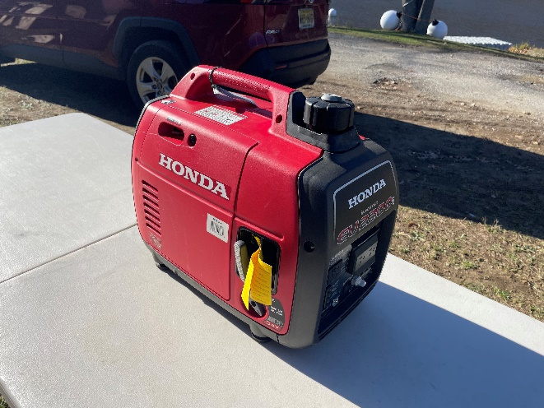

* 1. Surge protector
     1. May need more depending on number of boats

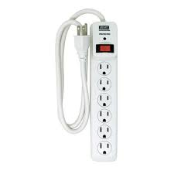

* 1. Extension cord

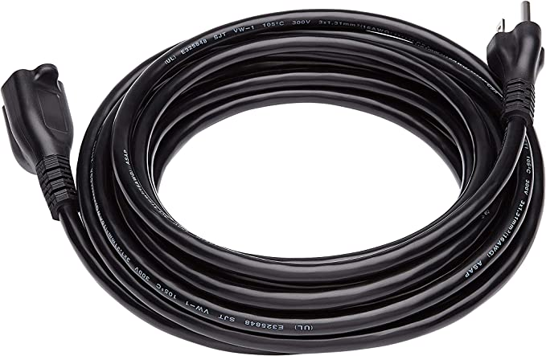

* 1. Radio mast, serial number SR1.8-014 or (ADD OTHER SERIAL NUMBER HERE)

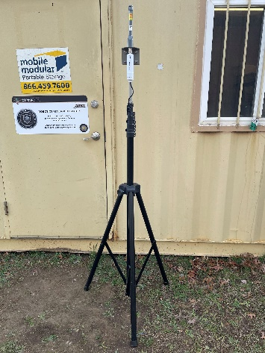

* 1. Assorted Ethernet Cables
     1. May need more depending on number of boats and devices that need to be connected to the network

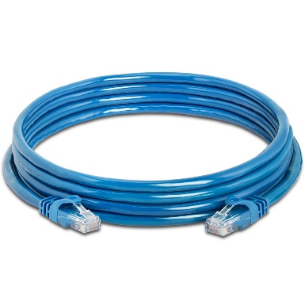

* 1. (Optional) Mi-Fi and Mi-Fi charger.
     1. Mi-Fi accepts any usb-c cable and charging block

|  |  |  |
| --- | --- | --- |
|  |  |  |

1. Set up generator downwind and at a distance from work area so sound and exhaust fumes don’t bother you while you work.
2. Set up radio mast on the dock of Lake Popolopen. The radio mast should be place in a way that minimizes interference with walkway on dock. See images below for recommended position.

|  |  |  |
| --- | --- | --- |
|  |  |  |

## Generator

1. Start Generator
   1. Ensure generator has enough gasoline
      1. Additional gasoline can be found in flammable material cabinet located next to Conex container near lake Popolopen. (INSERT PICTURE OF FLAMMABLE MATERIAL CABINET NEAR CONEX)
         1. Gasoline is in red fuel canisters
         2. Diesel is in yellow fuel canisters

|  |  |
| --- | --- |
|  |  |
| Gasoline Canister | Diesel Canister |

* + 1. (INSERT INSTRUCTIONS ON HOW TO USE SURE CAN CANISTERS)
  1. Choke the generator by moving choke lever to the right-most position

|  |  |
| --- | --- |
|  |  |
| Open Choke | Closed Choke |

* 1. Turn the fuel cap switch to the “ON” position

|  |  |
| --- | --- |
|  |  |
| Fuel Cap “OFF” Position | Fuel Cap “ON” Position |

* 1. Turn the engine switch to the “ON” position (INSERT PICTURE OF ON/OFF SWITCH)

|  |  |
| --- | --- |
|  |  |
| Engine Switch “OFF” Position | Engine Switch “ON” Position |

* 1. Quickly pull the pull start cord until the engine starts

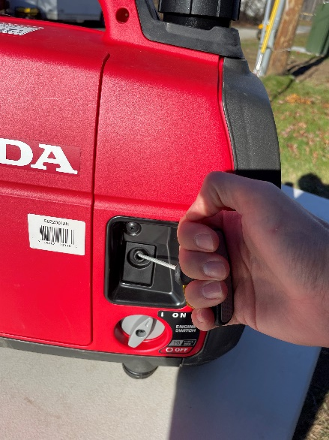

* 1. Once engine is on SLOWLY open the choke by moving the choke lever back to the left most position

|  |
| --- |
|  |
| Open Choke |

* 1. Switch the Eco Throttle switch to the “ON” position
     1. You will hear the engine become quieter and throttle down. You may also hear the engine rpm “pulse”. This is normal as the generator is throttling its power in order to provide the minimum power needed to supply your electronics in order to save fuel.

|  |  |
| --- | --- |
|  |  |
| Eco Throttle Switch “OFF” Position | Eco Throttle Switch “ON” Position |

1. Plug extension cord into generator and plug surge protector into extension cord. Place surge protector on table.
2. Open pelican case and remove the laptop, radio ethernet cable, laptop ethernet cable, pelican case power cable, laptop power cable, and the controller.
3. Attach the pelican case power cable to the pelican case and plug the cable into the surge protector.

# Networking

## Network Basics / Network Description

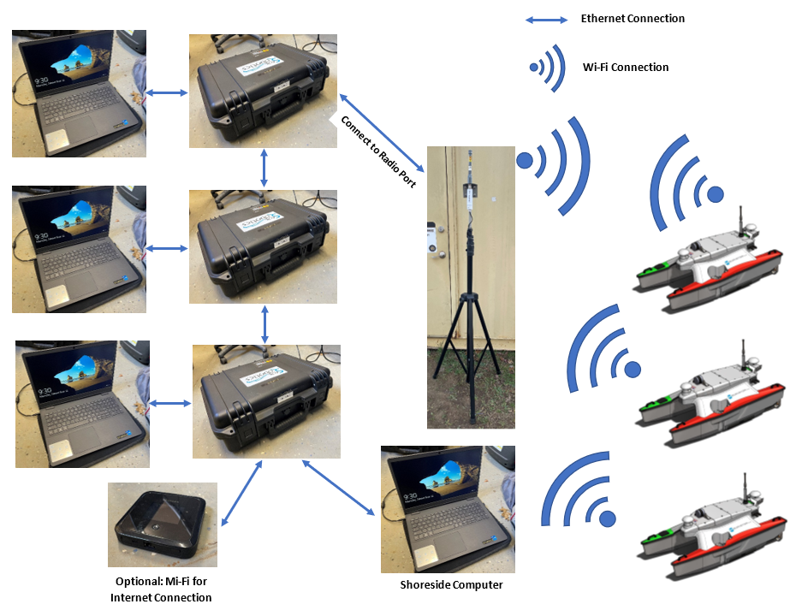Below are three typical networking set ups for the Surveyors.

**Light Weight Setup**

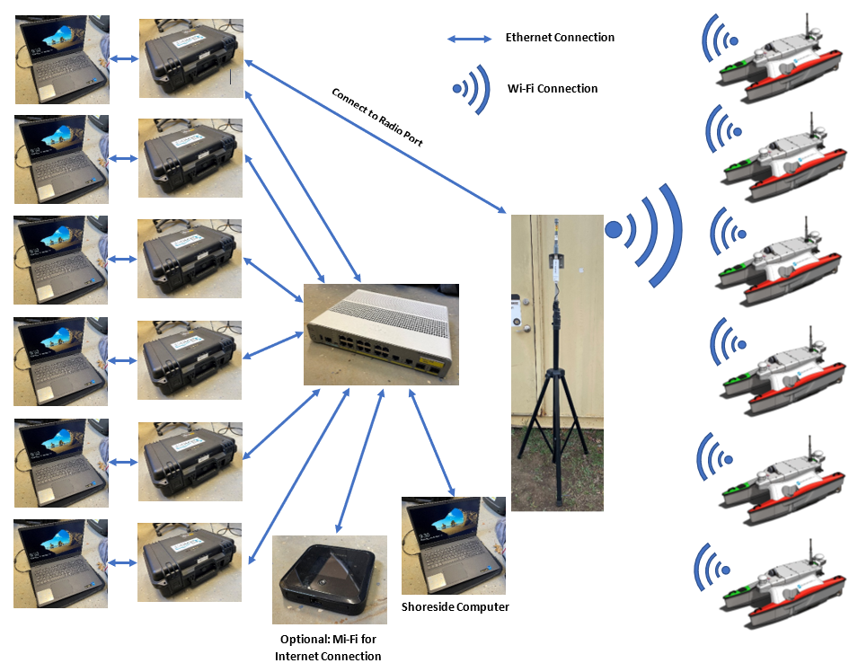

**Heavy Weight Setup**

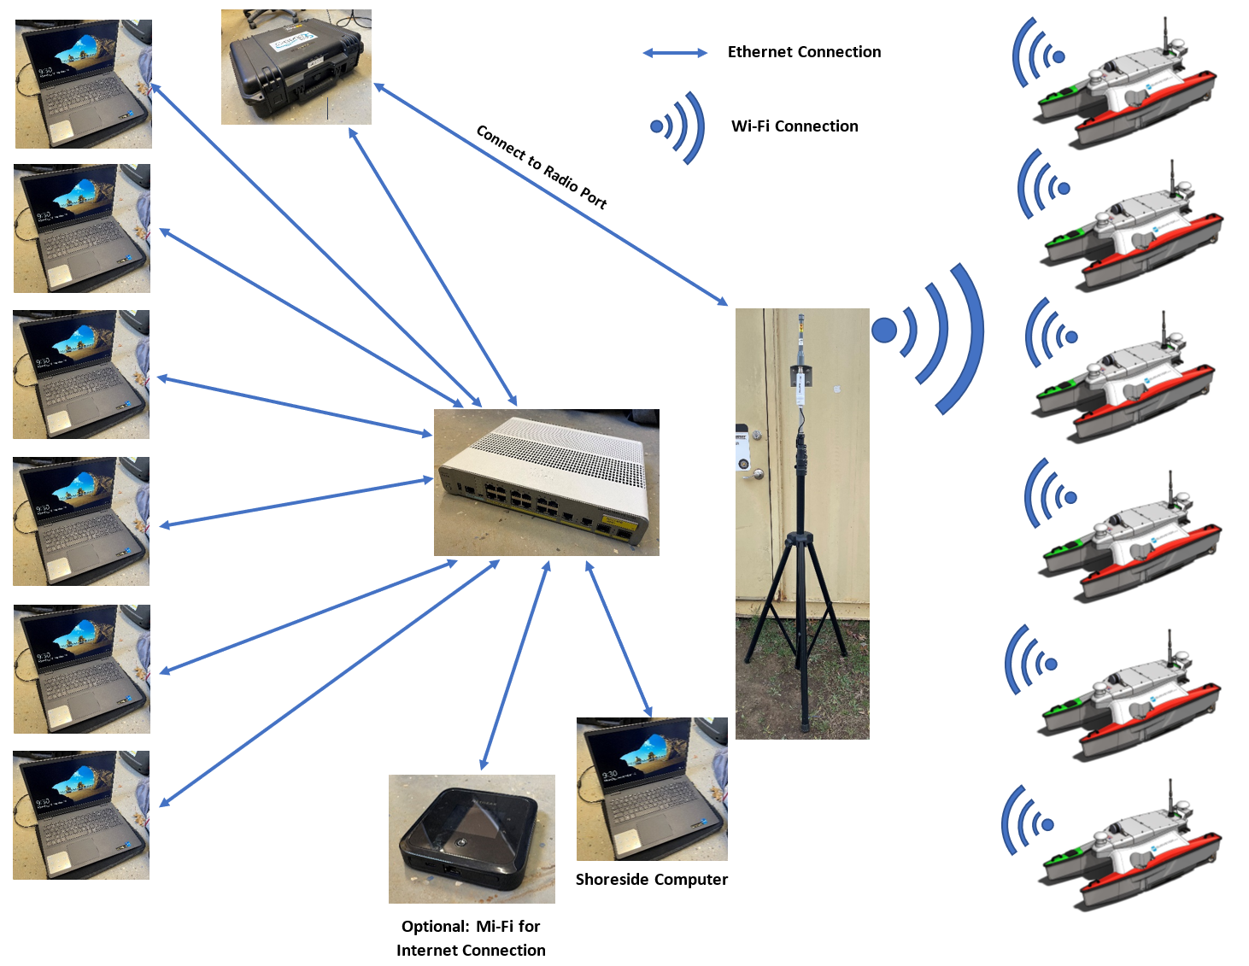

**Alternate Heavy Weight Setup**

Each boat has an Ubiquiti Bullet that is assigned an IP address. The IP addresses for the boat should all be the same except for a change in the second to last number of the address. See the table below, and you should be able to understand the pattern. The second to last number of the IP address corresponds to the boat number.

|  |  |  |
| --- | --- | --- |
| Boat Number (Serial Number) | Back-Seat Computer / DAC IP Address | Front-Seat Computer / Motor Controller IP Address |
| 01 (SR1.8-007) | 192.168.1.12 | 192.168.1.11 |
| 02 (SR1.8-008) | 192.168.1.22 | 192.168.1.21 |
| 03 (SR1.8-009) | 192.168.1.32 | 192.168.1.31 |
| 04 (SR1.8-010) | 192.168.1.42 | 192.168.1.41 |
| 05 (SR1.8-011) | 192.168.1.52 | 192.168.1.51 |
| 06 (SR1.8-012) | 192.168.1.62 | 192.168.1.61 |
| 07 (SR1.8-014) | 192.168.1.72 | 192.168.1.71 |
| 08 (SR1.8-015) | 192.168.1.82 | 192.168.1.81 |

Each boat is connected to a central network via a Wi-Fi link between their Ubiquiti Bullet and an on-shore Ubiquiti Bullet. The onshore Ubiquiti bullet’s IP address is 192.168.1.9.

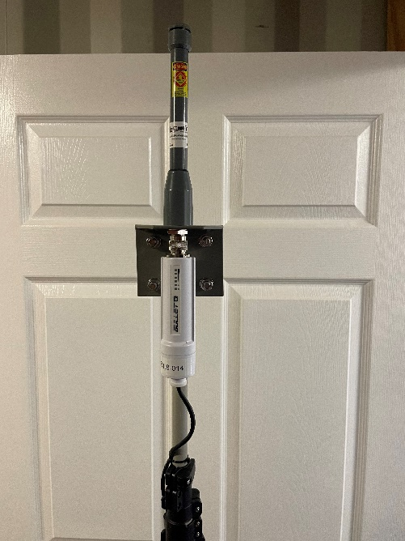

This bullet is then connected into the radio port on any of the several pelican cases that are for each boat.

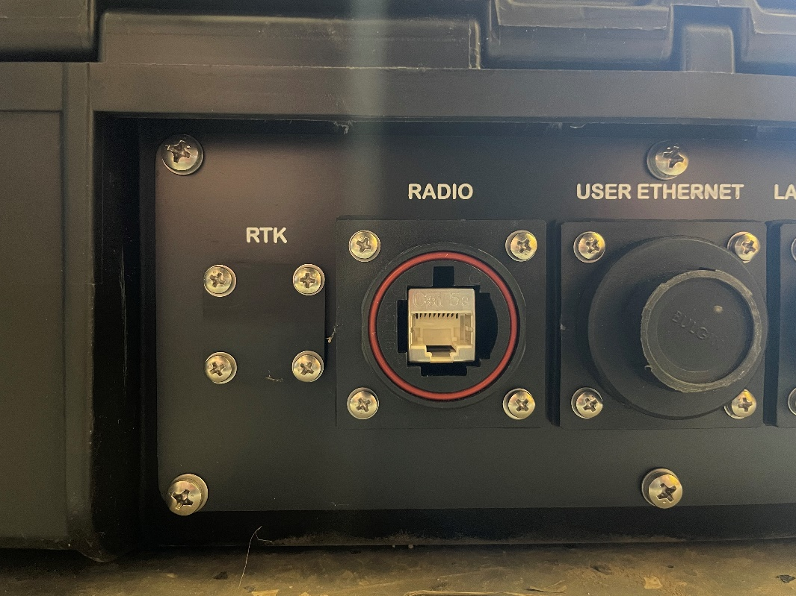

Inside each pelican case is a network switch.

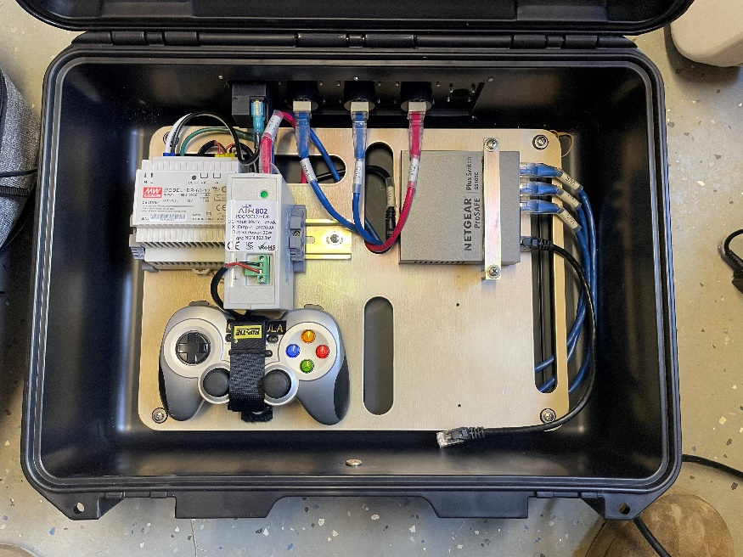

Network Switch

The network switch has 5 ports. One of which is connected to the internal power supply of the pelican case which then interfaces with the external facing ethernet port labeled “Radio”. This is to supply power over ethernet to the on-shore Ubiquiti Bullet. Two of which interface directly with external facing ethernet ports at the back of the pelican case. The two remaining ethernet ports on the switch are open.

There are two ways that can be used to network the boats. There is a lightweight setup, and a heavyweight set up. The lightweight setup consists of using solely the network switches internal to each case. This method is very portable and is ideal when only using a few boats, for quick experiments. The heavy weight setup consists of using an external network switch.

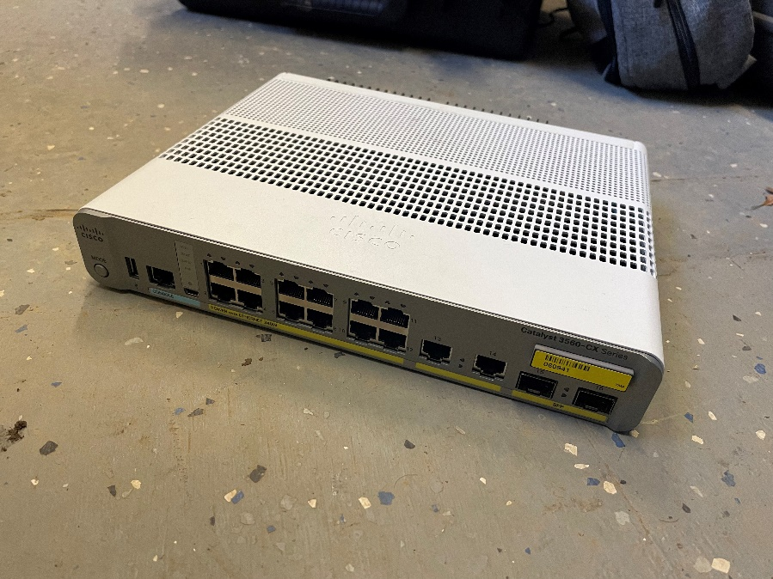

This setup is better suited for use with multiple boats, and when multiple people need to connect their laptops to the network. The lightweight setup when used with a larger number of boats can become cumbersome and hard to track which ethernet cable is plugged into which network switch.

To operate the Surveyor:

* Each companion computer needs to be connected to the network.
* An onshore Ubiquiti Bullet needs to be connected to a pelican case radio port.
* The pelican case needs to be connected to the network.
* A laptop that will be operating the shoreside environment needs to be connected to the network.
* Finally, the Ubiquiti Bullet on each surveyor needs to be communicating with the on-shore Ubiquiti Bullet.

This should happen automatically if the following conditions are met:

* The Surveyor is on and has finished its initialization sequence
* The onshore Ubiquiti Bullet is plugged into the radio port, and the pelican case is on.
* The IP address of the primary computer is set, and the IP address of the onshore Ubiquiti Bullet is set properly.

When the indicator lights on the Ubiquiti Bullet are fully lit on both the Surveyors and the onshore Ubiquiti Bullet, you should be able to at minimum to manually control the boats.

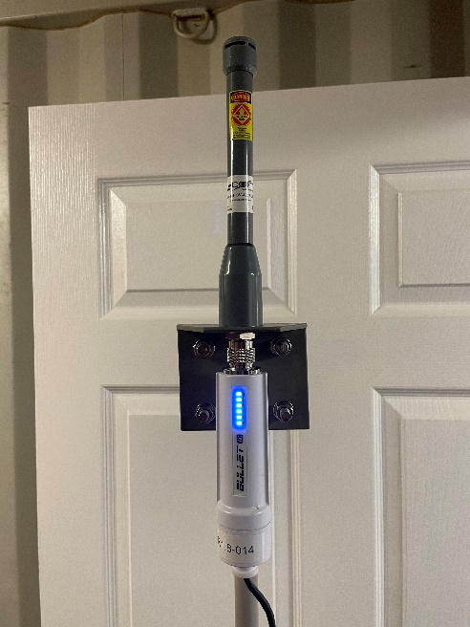

## Setup for the Ubiquiti Bullet

To make the all the Ubiquiti Bullets communicate properly, they need to be configured with the right settings. There should be two radio mast Ubiquiti Bullets that are currently configured correctly; serial number SR1.8-014 and (INSERT SECOND SERIAL NUMBER HERE). To access the Ubiquiti Bullet settings, you need to type in the IP address of the bullet into an internet browser on any computer that is connected to the Ubiquiti Bullet. If you are unsure what the IP address is of the Ubiquiti Bullet you are trying to access, there are ways to discover it. You should first try to ping your own broadcast IP address which is typically 192.168.1.255. This will display the IP addresses of other devices on your network. Additionally, a useful command line tool is, “arp -a” which shows all the IP addresses that are currently interfacing with your computer. The “arp -a” command should work on both Windows and Linux systems. The IP address of the Ubiquiti bullet should look something like “192.168.xxx.xxx”. You may have to test several IP addresses that appear by using the “ping” command until you get a response.

# Controller

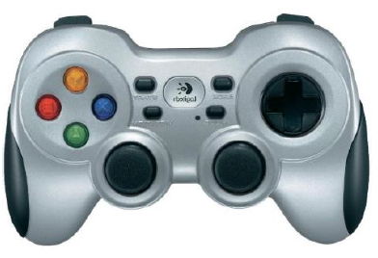

* Prior to starting SRC GUI utility press the “MODE” button twice to wake the controller joystick or try pressing down on the joysticks.
* If the joystick is not operating in SRC GUI, exit the GUI, press the mode button on the controller twice, then reopen the GUI
* Press mode button to see if indicator LED lights up. If the indicator LED is solid green, there should be a connection to its companion laptop. Press the mode button one more time so that the indicator LED turns off to use the joysticks to control the robots.
* If the batteries on the joystick are low the mode indicator light will blink every few seconds

|  |  |
| --- | --- |
|  |  |

* If the controller is not connecting to the laptop try removing the small Logitech USB device and re-inserting it into a USB slot.

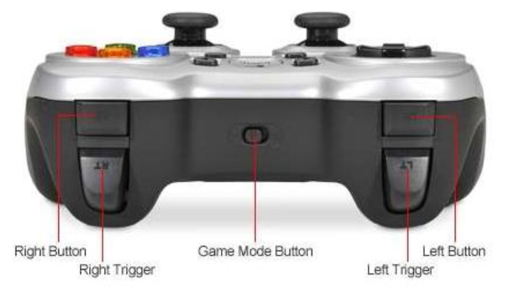

* The “Game Mode Button” must be in the “D” position. If the switch is not in the “D” position the ASV motions will be unpredictable

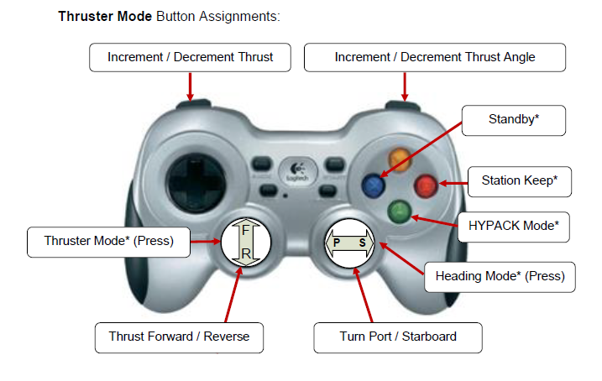

* The vessel can also be operated via the up/down/left/right arrows on the keyboard should the joystick become inoperable.

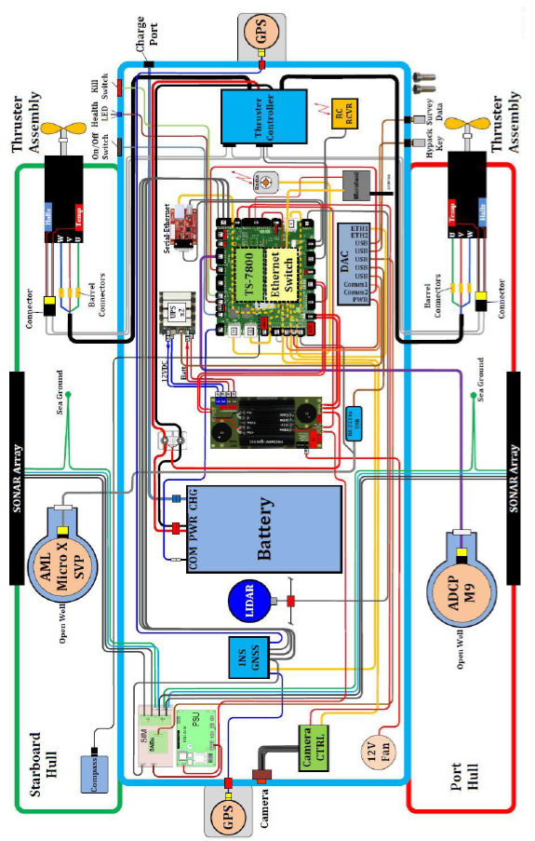

# Wiring Diagram

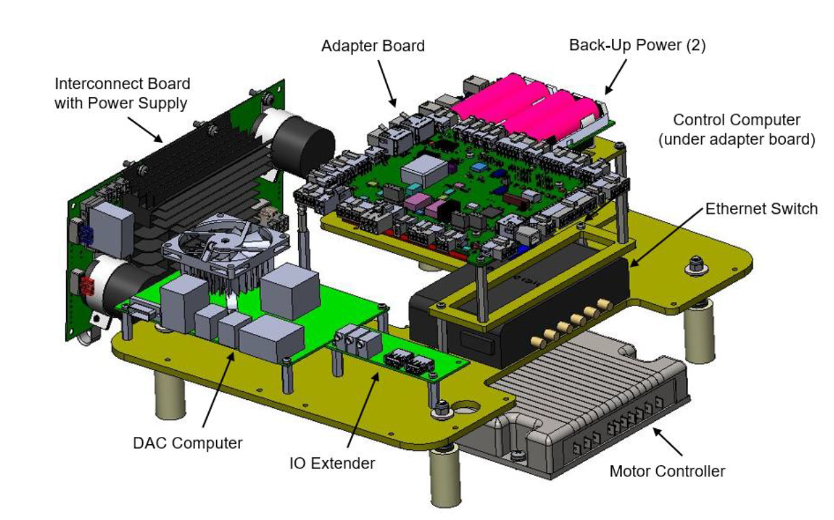

# Rear Compartment Contents

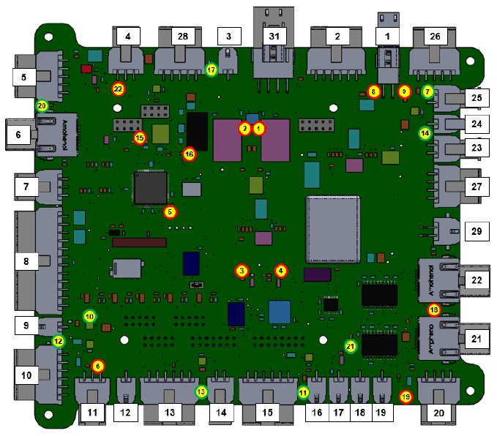

# Adapter Board with Labeled Ports and LED Health Indicators

|  |  |
| --- | --- |
| **Description** | **LED No.** |
| UPS 1 power in use | 1 |
| UPS 2 power in use | 2 |
| INS PPS | 3 |
| INS Tx Transmit | 4 |
| Microprocessor Health (LED Blink => OK) | 5 |
| IMU/AHRS power (not used) | 6 |
| SVP power | 7 |
| Adapter board power, 24 v (LED ON => PWR On) | 8 |
| Adapter board power, 12 v (LED On => PWR On) | 9 |
| Edgetech Sonar (to power board relay) (LED On = PWR On) | 10 |
| Thruster Kill Switch (LED On = closed) | 11 |
| INS/GNSS power and data | 12 |
| ADCP power | 13 |
| DAC power | 14 |
| 3.3 v power supply (LED On => PWR On) | 15 |
| 5.0 v power supply (LED On => PWR On) | 16 |
| RC Controller (LED On => PWR On) | 17 |
| Radio POE (LED On => PWR On) | 18 |
| ON / OFF Switch | 19 |
| LIDAR – power | 20 |
| Health LED (LED On => health pulse) | 21 |
| GNSS RS232 Eth. Converter – power (LED On => PWR On) | 22 |

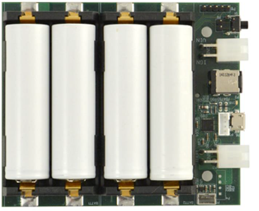

# Uninterruptable Power Supply

* A green and red LED are mounted next to the USB port.
* A solid green LED indicates that the UPS is operating from the vessel battery.
* A solid red LED indicates that the UPS is operating from the onboard UPS board.
* A solid green and a solid red LED indicates that one or more of the UPS batteries is outside of its nominal characteristics.
* Occasionally the boats will not shutdown and run of the UPS for a few minutes and should typically shutdown on its own. If this process takes an extended period of time (more than 2-3 minutes) contact SeaRobotics Support.

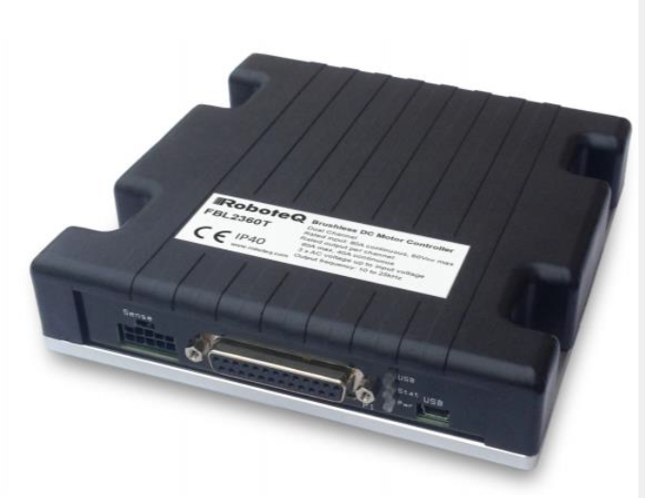

# Motor Controller

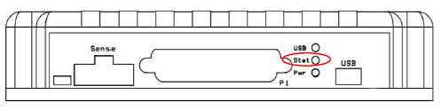

* Three LEDs are located on the front of the motor controller. The top one indicates the status of the USB port, the middle one is a status indicator, and the bottom LED indicates that the unit has power.

Status LED during normal operation (idle mode => 2 seconds ON, 2 seconds OFF)

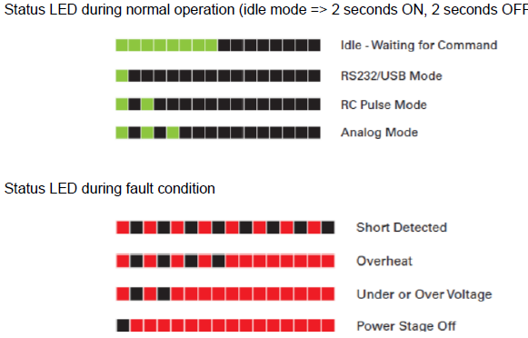

Status LED during fault condition



# General Maintenance

* Fasteners tightened with hand tools only
* It’s generally advisable to charge batteries fully before beginning to use the batteries
* When in long term storage remove all connections from battery
* Keep batteries charged when not in use
* Charge batteries regularly
* Avoid running batteries when they’re low
* Don’t leave batteries discharged for extended periods of time
* Keep batteries out of high heat
* Store batteries in cool dry place
* Battery service life last around 2-3 years
* When performing maintenance on vehicles it is best to have power off if possible
* Metal fasteners on external surface should be waxed with metal wax to avoid rusting / corrosion
* Keep boat hull clean and waxed
* Patch any crack that occur due to stress, age, or accident
* Inspect electrical connections for cleanliness and tightness
* After extensive use (multiday missions) inspect hull and electrical enclosure integrity
* Open all compartments and inspect for water intrusion
  + If water is present inside the vessel, power vehicle off immediately, and use towels or rags to remove water before powering on
  + Water should never be present in any compartment
* Inspect for loose or damaged internal components
* Inspect for damage on hatches, and gaskets
* Raspberry Pi at front of boat is camera processor

# Thruster Maintenance

* DO NOT INSPECT OR SERVICE THE THRUSTERS WITH THE VEHICLE TURNED ON. FAILURE TO COMPLY COULD RESULT IN SEVERE INJURY AND DISMEMBERMENT
* Ensure propellers and shafts are free of debris
* Ensure props locknuts and nylons washer are in place
* Ensure thruster locking pin and nut are in place
* Thruster assembly is removed by removing single thruster locking pin and pulling out thruster assembly

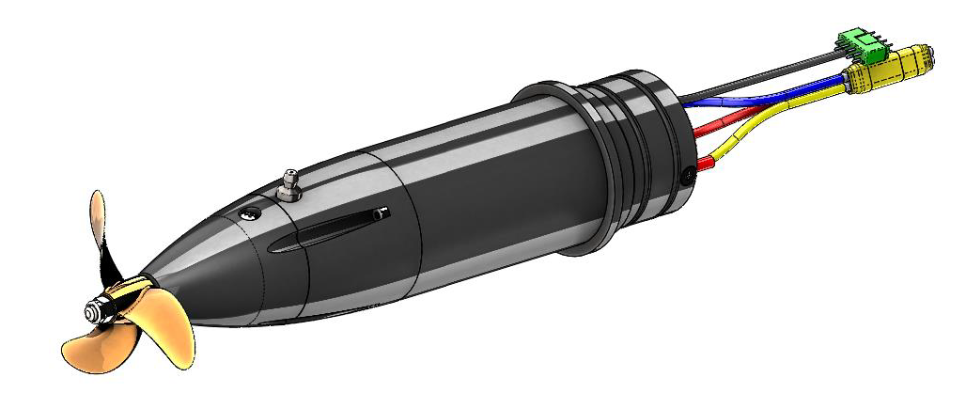

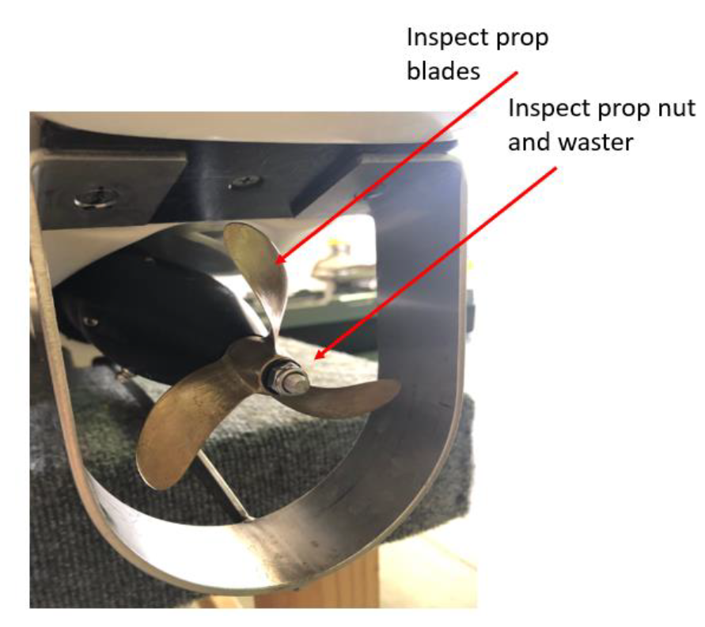

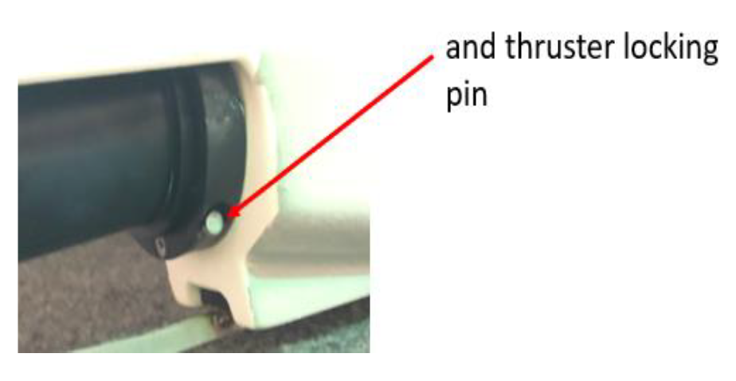

* Thrusters require replacement of primary shaft seals every 400 hours of operation or every 18 months whichever comes first
* Replacing Thruster Shaft Seals
  + Remove prop nut using a 10mm socket
  + Remove nylon washer, prop, and prop pin from shaft
  + Remove (2) Seal hub retaining screws and (1) grease blead screw
  + By hand, physically pull the seal retainer aft removing it from the thruster

|  |  |
| --- | --- |
|  |  |
|  |  |

* Grease the shaft log every 500 hours:
  + First removing the grease bleed screw from the starboard side of the thruster housing
  + Locate the grease fitting located on the port side of the thruster housing.
  + Using a grease gun, fill thruster tube with grease until clean grease is seen exiting the grease bleed screw port. Once complete reinstall the bleed port screw.
* DO NOT OPERATE THE VESSEL WITHOUT THE BLEED PORT SCREW INSTALLED
* Use LUCAS Marine Grease and Applicator

|  |  |
| --- | --- |
|  |  |

|  |  |  |
| --- | --- | --- |
| Pop U Parts List | | |
| Part Description | URL | **Image** |
| Motor Shaft Shear Pin | https://www.mcmaster.com/91585A226/ |  |
| McMaster Part Number  91585A226 |
| 18-8 Stainless Steel Dowel Pin / 2 mm Diameter, 14 mm Long |
| Off-White Nylon Unthreaded Spacer – Battery Panel Washer | https://www.mcmaster.com/94639A249/ |  |
| McMaster Part Number  94639A249 |
| 3/8" OD, 1/16" Long, for Number 10 Screw Size |
| Thumb-Screw-Head Captive Panel Screw – Battery Panel Fastener | https://www.mcmaster.com/91035A460/ |  |
| McMaster Part Number  91035A460 |
| 10-24 Thread Size, 5/8” Long |
| Retainers for 10-24 Thread Size Captive Panel Screws – For Battery Panel Fastener | https://www.mcmaster.com/91065A680/ |  |
| McMaster Part Number  91065A680 |
| N/A |

|  |  |  |
| --- | --- | --- |
| Surveyor Parts List | | |
| Part Description | URL | **Image** |
| Motor Shaft Shear Pin | https://www.mcmaster.com/91585A226/ |  |
| McMaster Part Number  91585A226 |
| 18-8 Stainless Steel Dowel Pin / 2 mm Diameter, 14 mm Long |
| Off-White Nylon Unthreaded Spacer – Battery Panel Washer | https://www.mcmaster.com/94639A249/ |  |
| McMaster Part Number  94639A249 |
| 3/8" OD, 1/16" Long, for Number 10 Screw Size |
| Thumb-Screw-Head Captive Panel Screw – Battery Panel Fastener | https://www.mcmaster.com/91035A460/ |  |
| McMaster Part Number  91035A460 |
| 10-24 Thread Size, 5/8” Long |
| Retainers for 10-24 Thread Size Captive Panel Screws – For Battery Panel Fastener | https://www.mcmaster.com/91065A680/ |  |
| McMaster Part Number  91065A680 |
| N/A |

|  |  |  |
| --- | --- | --- |
| Phillips Flat Head Screws for Sheet Metal – External Fasteners for cup holders, and motor attachment points | https://www.mcmaster.com/90198A249/ |  |
| McMaster Part Number  90198A249 |
| Super-Corrosion-Resistant 316 Stainless Steel, Number 8 Size, 1" Long |
| 316 Stainless Steel Extra-Wide Truss Head Phillips Screws – Forward and Rear Compartment Fasteners | https://www.mcmaster.com/94792A626/ |  |
| McMaster Part Number  94792A626 |
| 10-32 Thread, 1" Long |
| Nylon Plastic Washer – Washer for Forward and Rear Compartment Fasteners | https://www.mcmaster.com/90295A420-90295A421/ |  |
| McMaster Part Number  90295A420 |
| Number 10 Screw Size, 0.193” ID, 0.438” OD |
| Bulgin - PX0733 – Ethernet Port Cover for Pelican Cases | https://www.newark.com/bulgin/px0733/sealing-cap-polyamide/dp/48F2467 |  |
| Newark Part Number  48F2467 |
| Dust Cap / Cover, Sealing Cap, Ethernet Buccaneer Panel Connectors, 6-pole |
| Bulgin - PX0870 – Ethernet Port for Pelican Case | https://www.newark.com/bulgin-limited/px0870/panel-mount-ethernet/dp/95AJ9937?st=px0870 |  |
| Newark Part Number  95AJ9937 |
| Panel Mount Ethernet |

|  |  |  |
| --- | --- | --- |
| Sea Robotics Support Contacts | | |
| **Sea Robotics Contact** | **Description** | **Email** |
| Sea Robotics Support | General Support | [support@searobotics.com](mailto:support@searobotics.com) |
| Lou Dennis | VP of Programs (Contact if Support is Unresponsive) | [ldennis@searobotics.com](mailto:ldennis@searobotics.com) |
| Kevin Kirchner | Engineering Technician (Contact if Support is Unresponsive) | [kkirchner@searobotics.com](mailto:kkirchner@searobotics.com) |
| Hal Dewar | Engineer (Contact if Support is Unresponsive) | [hdewar@searobotics.com](mailto:hdewar@searobotics.com) |
| Bill Jones | Electrical Engineer (Contact if Support is Unresponsive) | [bjones@searobotics.com](mailto:bjones@searobotics.com) |
| Ron Holman | (Contact if Support is Unresponsive) | [rholman@searobotics.com](mailto:rholman@searobotics.com) |

|  |  |  |
| --- | --- | --- |
| Change Log | | |
| Version | Changes | Date |
| 1.0 | Creation of Document | 09/06/2022 |
| 1.1 | Added to parts list | 11/08/2022 |
| 1.2 | Added to UPS, Added Table of Contents | 11/10/22 |

# Future Additions/Changes:

Need to add section on GUI on laptop.

Add instructions for what to do when receiving a new boat

Add instructions for networking

Add instructions for operation

Add General Information

Add instructions for handling boats (in particular the ubquiti bullet and not to twist it and to remove antenna for storage)

Add section for passwords

Add instructions for setting up tent